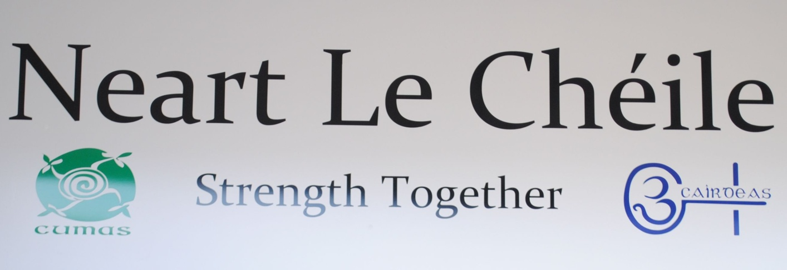

Neart Le Chéile
Annual Report
2019

Old Supermarket, 1-2 Neilstown Shopping Centre,
Clondalkin, Dublin 22
Tel: 01-457-3515

Chairperson’s Foreword

Welcome to the Neart Le Chéile - Annual Report 2019. This year the two services, the Cumas project and the Cairdeas project continue to offer services to families and individuals.

- Cumas works with families, parents, grandparents, guardians, teenagers and children from aged 4 upwards.
- This work is completed in a number of ways: play therapy, one to one sessions, group work, counselling support, home visits, schools support, supports around assessment of needs, financial, social and emotional support. The service is implemented on a need led basis with a holistic wrap around service provided for families and individuals.
- The service offers a number of specific programmes annually or when the need is identified. These include Parents Plus, WRAP (Wellness Recovery Action Plan), Bereavement support, Cognitive Behavioural Therapy (CBT), REAL U Sexual health programme.
- We also have a number of staff trained in the Tusla Meitheal National Practice Model. This has supported a number of families we work with in 2019.
- Cumas aims to work through an inter agency approach. This includes being involved on certain committees such as: South and North Clondalkin Tulsa led family support networks, South and North Clondalkin young people at risk (YPAR), JIGSAW mental health advisory group.
- SUDS (Service Users Developing Solidarity) members were also busy this year. They participated in in stress management, harm reduction workshops and First Aid Training
- Overdose awareness and prevention as part of International Overdose Awareness Day; participants were training in the use of naloxone facilitated by Owen Glesson and Dennis O’Discroill Chief Pharmacist Dr Cathal O’Sullivan with the support of Eamon Keenan HSE and Jennifer Clancy CDATF.
- Suds members participated in the Clondalkin Drug & Alcohol Task Force Launch of the Clondalkin Model, in which SUDS showed they film the Bus Stop Here.
- SUDS attended a Play in Abbey Theatre ‘Last Orders at The Dock’
- SUDS facilitated a fundraiser in aid of Hope Foundation for an addiction service in India in Conjunction Pranic Healing.
- Pop up Recovery café was held on the 3rd December 2019 was a great success with live music, pranic healing, massages, angle card reading and food. A great night was had by all who attended. Suds conjunction Paul Duff from Recovery Academy promoted the pop up café to support people to socialise and to overcome stigma.
These are just some of the highlights of 2019 and I would sincerely like to thank all those who have supported Neart le Chéile in the course of this and previous years. The board and staff of Neart Le Chéile look forward to your continued support in 2020, as we continue to work with those families engaging with our services as they deal with the issues they face as a result of drug use.

Yours gratefully,

TABLE OF CONTENTS

Section |  | Page
 | Foreword | 2
 | Mission Statement | 4
1 | Introduction & Overview | 5
2 | Neart le Chéile- The Cumas Project | 7
3 | Neart Le Chéile- The Cairdeas Project | 22
4 | Networking and Coordination | 29
5 | Neart Le Chéile- Governance | 32
6 | Financial Summary | 34
7 | Thank You | 37

Mission Statement

“To promote equality by creating and facilitating supportive services which build the capacities of families and individuals to make changes to their lives and circumstances in a way which addresses and reduces the negative consequences arising from the use of drugs in Clondalkin.”

1 Introduction & Overview
1.1 Introduction
Neart Le Chéile (Strength Together) is a community based organisation, which provides two services; Cumas project which works to support children and families who experience addiction within their families and Cairdeas project which works with people who use drugs or have a history of drug use on issues that impact on their lives. The company is working hard to continue to maintain and develop quality services for the community we serve.
The board of Neart Le Chéile meets on a monthly basis and is very active in the management of the organisation. It works hard to support the staff in delivering a quality service by continuing to review and plan the work of the organisation on a regular basis. It has a number of sub-groups with defined areas of focus, such as HR and Finance.
1.2 Overview
People who access the service are dealing with the impact of poverty trying to make ends meet while living on social welfare or low income. Housing and homelessness are still causes for concern for families. Some families are living in overcrowding situations, which can add to their stress levels. Single people are also finding it hard to access accommodation in the local area due to affordability and availability which has resulted in some people sofa surfing or sleeping rough. Some people express that they are experiencing anxiety and stress trying to cope with the situations they are living in which is causing concerns for their mental health.

1.3 Catchment Area
The area in green indicates the Electoral Divisions covered by Neart Le Chéile (Clondalkin Village, Dunawley, Monastery, Cappaghmore, Rowlagh, Moorfield and Palmerstown West- Quarryvale):

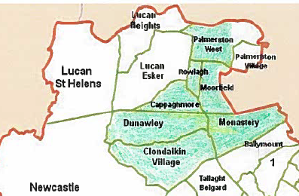

2 Neart le Chéile: The Cumas Project

The Cumas Project was established in 1998, under the Education and Prevention Strategy of Clondalkin Drugs Task Force Action Plan, as an intervention and prevention service for families affected by the consequences of drug use. Over the past twenty years this distinctive project has grown and developed greatly. Cumas works with all family members from young people aged four years and up, to grandparents. Cumas is unique as it is the only service in the Clondalkin area to provide a service to young people aged 4 + - 18 years, who are affected by the consequences of drug use within their families.

2.1 Area Profile of families
Area Profile | Families  2017 | Families  2018 | Families  2019
South West Clondalkin | 35 | 20 | 21
North Clondalkin | 30 | 25 | 26
Lucan | 11 | 6 | 4
Other | 6 | 3 | 2
Total | 82 | 54 | 53

2.2 Interventions used
Cumas works on a needs led basis offering a variety of interventions using a holistic and interagency approach. There are many elements to this work. In order to understand this better it is broken down as follows:
- Family work
- Individual work
- Group work
A large part of the work includes interagency work with other statutory and non-statutory agencies.
“Family support is about meeting the needs and achieving the rights of Children” UNESCO”
In 2019, 53 families engaged with the Cumas project with 92 individuals receiving indirect work over the course of the year; this has seen different members of the same family attending the service on different occasions for a number of services such as individual work, group work, and family sessions.
Below are two examples:
“I have gotten so much from the project, both me and the boys. It is really good to know that I am not alone and other people are going through the same as me. I'm not sure how to put it because saying it has been supportive and helpful is just too much of an understatement”.
What Cumas means: “Cumas is a home from home”
What Cumas does: “Builds me up when I'm broken and keeps me together”

When a family is referred, a needs assessment is carried out with family members, referrers and Cumas staff. This identifies what intervention/support is most appropriate to each family member. This can include individual work, group work and/or family sessions.
2.3 Case Management
Staffs operate a case management approach, develop responses to the needs of the family and adopt an interagency approach to their work.

Description | Attended session
Individual | 92 individuals x 42 = 3,864 sessions - on average one per week
Group | 4 groups x 22 individuals= 3,696 session  Each session last 1.5 to 2hrs. The session in the Summer go for long the depending on the activities. Some groups are bi weekly
Family session | 43 families sessions = 43 assessments
other meetings | 10 families x exit meetings
Reviews | 43 families review every six weeks = 425 reviews (extra meetings for some families)

The following table indicates how the service has developed over 2019.
 | b/f | Jan | Feb | Mar | Apr | May | Jun | July | Aug | Sep | Oct | Nov | Dec
Active Families | 40 | 41 | 42 | 45 | 47 | 50 | 53 | 51 | 49 | 46 | 45 | 44 | 43
New | 0 | 1 | 2 | 3 | 2 | 3 | 3 | 0 | 0 | 0 | 1 | 1 | 0
Closed | 0 | 1 | 0 | 0 | 0 | 0 | 2 | 2 | 2 | 3 | 2 | 2 | 1
Actual cases individuals direct work | 89 | 91 | 95 | 101 | 105 | 110 | 111 | 107 | 104 | 100 | 96 | 94 | 92

2.4 Assessment
An assessment of needs is carried out on each family and a six week plan is developed from this. After six weeks work the plan is reviewed between family members and Cumas staff and a future plan is made. This plan either recommends that Cumas continues its work with the family, or if it is felt that Cumas is not the most appropriate service, a referral to a more suitable agency is made.

2.5 Individual work
Individual work is carried out on a one to one basis with a young person or an adult. Individual sessions would be held on average once a week. (More details
next table)

2.6 Group work
Young people and adults while engaging in individual work or when completing individual work, may also attend a group. Groups are specific to the needs of service users. (More details below)

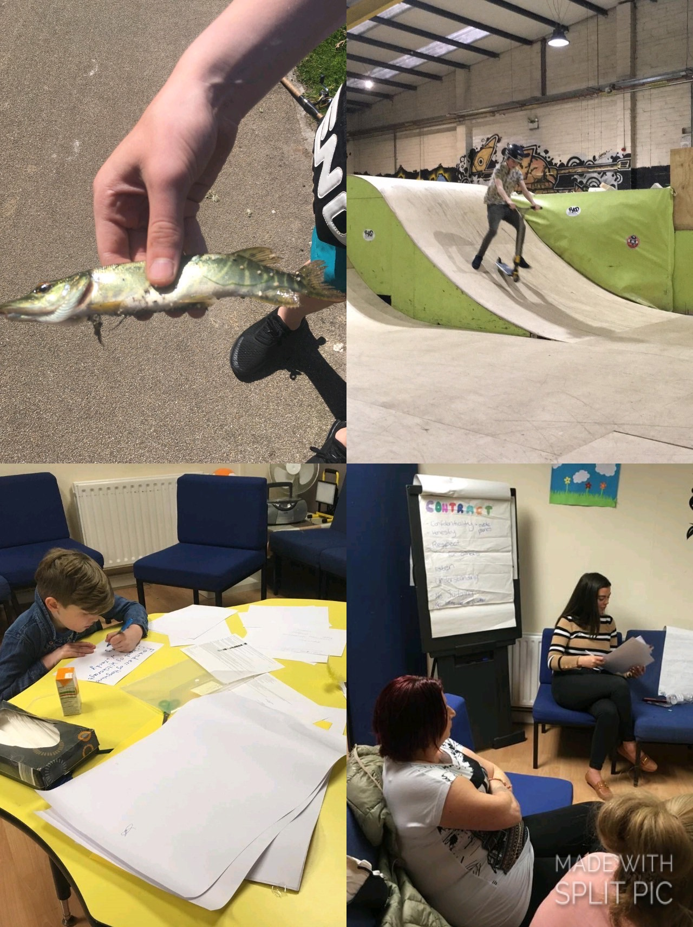
Picture: One to one work and group work

2.7 Family work/sessions
Family work is an essential part of the Cumas service as it encourages positive relationships between all family members. Sessions with families cover the issues and needs of the family. These can include issues such as; disagreements, school behaviour/ routine, attachment building, planning, rules, boundaries, parenting, life and family skills, fun, cooking etc. Family sessions can be either weekly or monthly. Family meetings including all family members are conducted to look at issues arising and to put plans in place to deal with those issues.

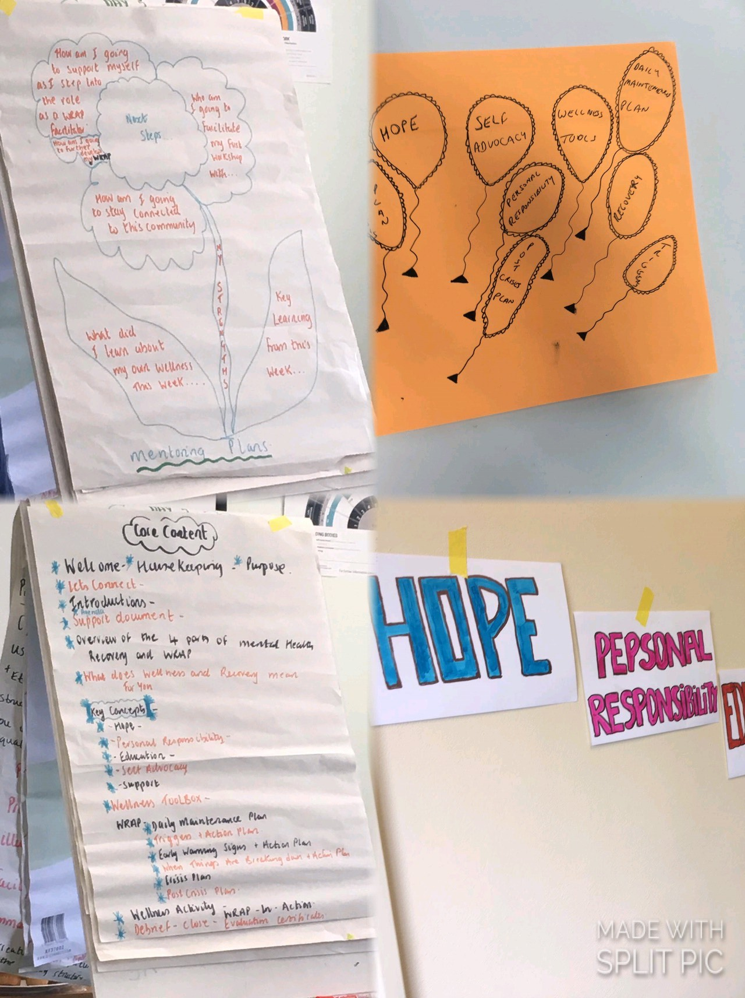
Picture above – New WRAP Training

The work carried out with families by Cumas is further illustrated below.
Examples of work with families are as follows:
Input | Output | Outcomes
Staff offered one to one support to all families.  - Staff carried out needs assessment with families.  - Staff offered practical support on issues families face  - Staff have participated in case conferences with the Child & family Agency  - Staff have engaged in Meithael process with a number of families | - 53 families accessed Cumas Project  - of family sessions were attended  - Care plans were completed or reviewed for all families over the course of the year.  - 10 families finished with Cumas Project  - A number Families were supported to access entitlements  - Staff supported families with housing issues, addiction issues, counselling and other needs arising | - Improved engagement with services  - Issues resolved, such as housing, welfare entitlements accessed.  - Improved communication  Improved family routine
- Staff works with a number of families, with HSE involvement for child protection (active) and some cases closed, as part of Social work care plan. | - Actively worked with the Tusla Social Worker together with Families to implement Care plan  - Cumas referred 19 cases duty Social Workers  - Interagency approach- HSE case conferences and Meithael attended | - All agencies involved working together  - Family focused clear care plan
- Staff while working with families may identify needs and make referrals to other parts of the Cumas service or other agencies within the community statutory /non-statutory  - Cumas staff also supported family members to access support from hospitals, GP, community based mental health services. While they are suffering from mental health or emotional crisis. | - Families counselling  - Play therapy  - Needs assessment  - Educational assessment  - Child protection concerns  - Psychological assessments  - Individual counselling  - Assessment of needs for children | - Improvement in parent/child relationships  - Safe space to explore feelings/situation  - New coping skills  - Extra supports put in place  - Referred to appropriate service while still receiving support from Cumas  - Links built with other services and work using interagency approach best outcomes for families achieved  - Supports put in place in school, etc. ensuring young people remain in education
- Staff represents the project on a number of forums. | - These include:  - North and South Clondalkin Young people at risk (YPARC)  - JIGSAW Mental Health Advisory Group  - North and South Clondalkin Family Support Network (CFSN)  - Other agencies that are relevant to the work of the service | - This interagency approach supports the best outcome for children and families  - Improved relationships with agencies in the community  - Better communication with agencies  - Inclusive wrap around support service

2.7 Referral & Assessment Process
Referrals are received from a variety of places such as; self-referrals (families refer themselves), statutory agencies and non- statutory agencies. Below is a list of all agencies we have received referrals from 2015 to 2019:

Referrals | 2015 | 2016 | 2017 | 2018 | 2019
Self-referrals | 53 | 59 | 50 | 38 | 43
Cairdeas | 3 | 2 | 2 | 1 | 2
CASP | 8 | 9 | 6 | 2 | 3
Clondalkin Tus Nua | 19 | 11 | 9 | 3 | 1
Dochas | 3 | 2 | 0 | 0 | 0
Extern | 2 | 2 | 0 | 0 | 0
Social Worker | 1 | 4 | 5 | 5 | 2
School | 6 | 10 | 10 | 0 | 2
Total | 81 | 99 | 82 | 54 | 53

Referrals (January- December 2019)
Cumas believes families have many strengths and coping skills, and staff work with families to support them to improve their skills as well as develop new skills to overcome the issues that they refer to the project with. The issues they face are wide and varied and the impact of these issues can be different for each family member.

Parental drug use can impact on children’s daily lives, emotionally and physically. There can be a lack of parental guidance, structures and/or routines. Emotional difficulties can be a result of any one of a range of issues including; bereavement within the family, parents separating, a family member going to prison, violent attacks on the home etc. There may also be welfare concerns, child protection concerns, lack of engagement with other services, difficulties in school, personal development, Grandparent parenting Grandchild, parental support, lack of engagement in school, at risk of losing a place in school, financial difficulties etc.

2.8 Individual Work
Therapeutic non-directive and directive play takes place in the Cumas play room using play therapy skills, mainly derived from training with the Children’s Therapeutic Centre. Individual work is also used with young people, adolescents and parents/grandparents. Interventions used include; life story work, sensory work, planned work, support, referral relating to individual’s needs and issues arising.
2.9 Group Work

On completion of individual work, as needs are identified a group is formed- normally with 4-6 participants. The group is created with a specific topic to be covered. Groups encourage peer interactions and social skills, while working on specific areas/issues. Child/adolescent, parent/ guardians and grandparents all attend groups. Many of the Cumas staff is fully trained in the Parents Plus parenting programme. Parenting groups take place at regular intervals in a group setting and support is offered on a one to one basis with parents. Parents’ support is an essential part of Cumas work. Two staff members were trained in the Wellness Recovery Action Plan (WRAP) in 2019. The aim of this is supporting service users to focus on their own wellness and how to implement this daily to support their mental health. This programme has been completed with a parents group and older teenagers in 2019.
The following are example of group work has been facilitated by Cumas staff
Input | Outputs | Outcomes
Group 1
15-16 Girls Group x 5  Sex Education  Personal Development  Education support  Bereavement  Housing support  Young mothers support | - Group thrived on group routine and structure  - Staff built relationships with young people  - A number of sexual health issues were identified in the community through this group setting. This was dealt with an interagency response. | - Improved confidence  - Improved engagement of families  - Improved interaction with Staff  - Improved interagency work on specific issue
Group 2
13/15yr group – teenager boys  Separation/loss group  Exploring changes  Using activity/art/cooking/sports | - 6 participated in group  - Use of art/group activities & discussions  - Group forming  - All had major changes in life and explored these  - Built resilience/good peer relationships | - Improved relationships in group  - Confidence built in all  - Explored changes, impact of these and coping skills  - Resilience built in all  - Peer understanding  - Focused on activity, completing tasks
Group 3

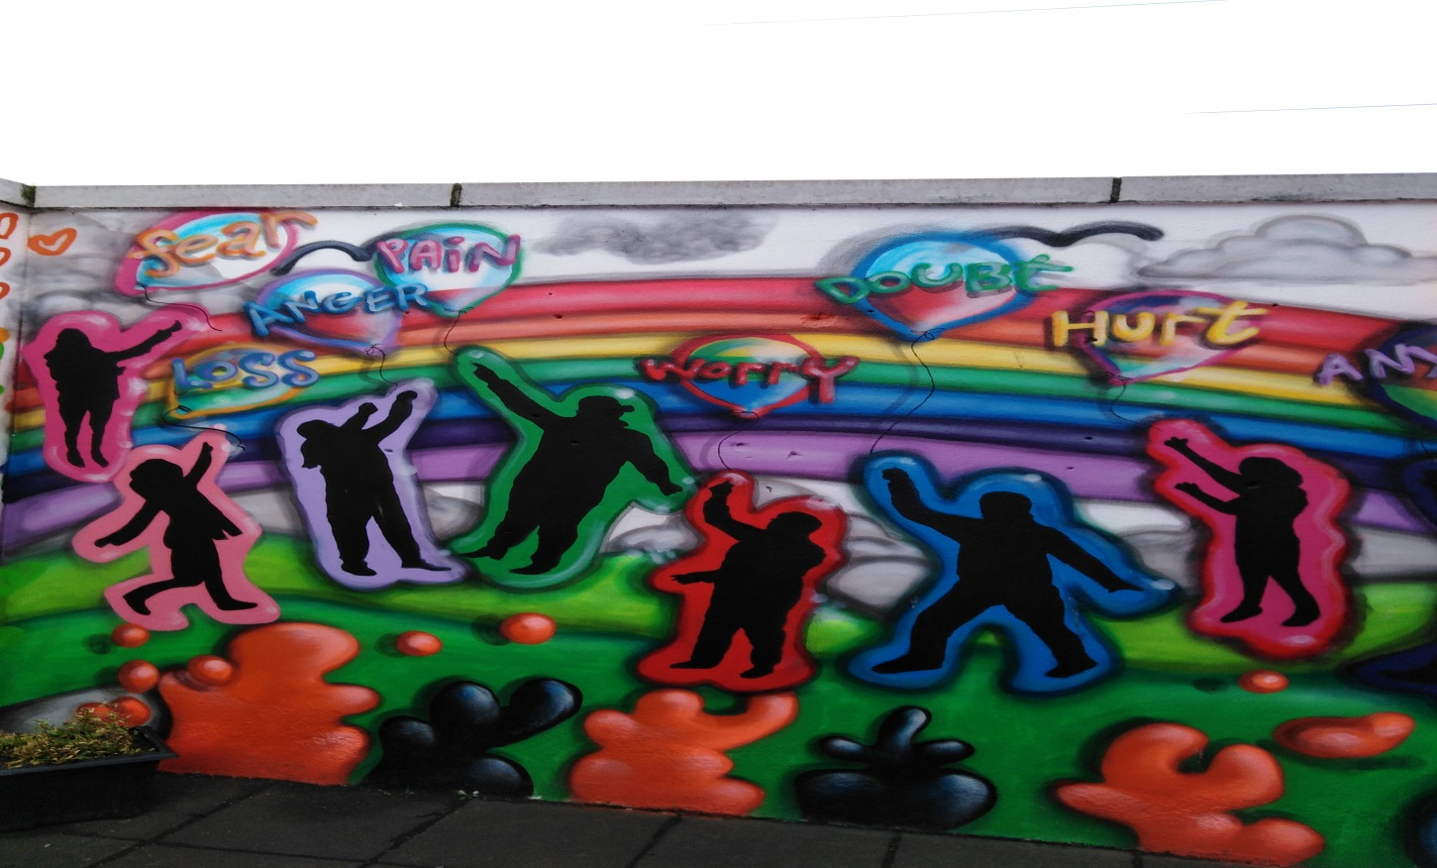

Parent Support Group
Parents Support group  Adults – (8 females)  Aim to develop support group for parents who are linked to Cumas service | - The group meet weekly.  - Developed new skills  - Managing budget (MABS)  - Drug Awareness  - WRAP Programme  - Participation in food bank  - Stress management  - Fundraising  - Healthy eating / mindfulness / yoga /Self care  - Parenting information | - Improved support system with peers  - New and improved confidence to try new things  - New ideas  - New sense of purpose working together to raise funds for a trip away  - Improved self –care  - Improved drug awareness and knowledge  - Greater community involvement  - Greater knowledge around self-care and wellness. Feedback was very positive for this

The Cumas project, as part of its need led service also offers families access to a counsellor and children access to play therapy as an extra support were possible and budget permitting. The service this year has continued to access Cross Care food bank. This has allowed Cumas to distribute food (some though EU initiative), which 31 families benefitted from this year.
The table below gives the breakdown of these therapies/ initiatives:

Inputs | Outputs | Outcomes
Family therapy

2/3 sessions per week  5 families engaged  Total of 11 people | - Two/three family sessions once per week  - Number of families (5)  - Families come together to deal with complex issues  - Safe space  - 6/8 weekly reviews with family, Cumas family key worker and family therapist, all information discussed with permission of family | - Improved communication  - Families supported to bring about change  - Staff supported families to maintain changes  - Ensuring best outcomes for all, clear work plan, goal setting, ensuring that Cumas staff give support where needed  - Ensuring therapy is appropriate and is meeting needs of family
Play Therapist

Provided to 7 (children) - existing service users  7 children were offered play therapy based on the needs of their family for twelve weeks | - Play therapist worked with the children giving support to deal with family circumstances, complex issues  - Child and family continue to engage in Cumas service. Most would have completed individual work but felt the need for additional support to deal with complex issues | - Improved understanding.  - Safe space  - Works at young person’s pace where they take the lead  - Time to work through issues in a non-threatening environment  - Less angry, better communication, happier, new coping skills, bereavement support
Food Bank

The service has developed links with the Cross Care foodbank  and has established a service in which 12 families pay a set amount and receive food once fortnightly. They also receive free food | - 12 Families  - Also 19 other families receive free food because of links to food banks  - Also the food bank offer extra support at different time of the year such as;  - School supplies  - Christmas hampers  - Halloween decorations | - Support Families out of food poverty  - Less financial stress  - Improved nutrition  - Greater involvement in the service.  - Support children to stay in school  - Help families celebrate  - Support the wellbeing of the family

2.11 Cumas Future Plans

- Continue to engage families from all areas of Clondalkin that are affected by drug use.
- Provide professional, structured and needs led interventions.
- Provide individual work for children, teenagers and adults.
- We have identified a significant amount of loss or bereavements in our families. A number of staff have now been trained in this area. We intend on engaging with families/children to support them very specifically in this area through the new knowledge and skills within the team.
- 2020 groups planned include; parents support group, parents plus, two teenagers groups (mentioned above), Older young adults group, WRAP programme. As needs arise new groups will be formed.
- Continue to work on an interagency approach offering supports and interventions as deemed necessary with statutory and non-statutory agencies ensuring best outcomes for families.
- Staff to sit on various committees relevant to Cumas work to represent the project.
- Continue to develop and review the interventions offered to families.
- Work on an interagency approach offering supports and interventions as deemed necessary with statutory and non-statutory agencies ensuring best outcomes for families.
- We have secured funding from the South Dublin County Council for a new sensory room for children and adults with extra sensory needs. This will be integrated into our 2020 plan. Staff will also be trained on how to use the sensory room effectively.

3 Neart Le Chéile- Cairdeas Project

Cairdeas Project is a community-based organisation which offers services to those who use drugs. The project works to community development principles and adopts a person-centered approach to its work. We promote harm reduction and seek to promote the full participation of people who use drugs in their community in order to break down the barriers to social inclusion. Cairdeas operates a low threshold service. Our services are as follows:
- An Advocacy Service
- SUDS -Service Users Developing Solidarity (a forum for people who use drugs)
- Stepladder Training Course.

3.1 The Advocacy Service
The Cairdeas Project Advocacy service is an ongoing process aiming to change attitudes, actions and policies by influencing people and organisation’s with power systems and structures at different levels for the betterment of those who use drugs. The service operates on a case-by-case basis in which staff will advocate on cases as they present to the project.
The Advocacy service has dealt with a range of issues in 2019, which include:
- Homelessness/housing/tenancy
- Access to education/training/employment
- Access to treatment, health and mental health
- Family and relationship issues – Court issues
- Access to Treatment
- Legal issues including letters of support for upcoming court cases and probation and welfare assessment reports on behalf of service users and family court

Area profile of those using the Advocacy Service
70 advocacy cases were dealt with throughout 2019 - 43 females & 27 Males
 | North Clondalkin | South West Clondalkin | Lucan | Other
Females | 16 | 19 | 3 | 5
Males | 16 | 5 | 4 | 2

Aim 1: Advocacy Service
Action | Outputs | Outcomes
Provide an Advocacy Service to those who use drugs or have a history of drug use on a case by case basis  Advocate on behalf of a person until the case is either resolved/ or satisfactory outcome sought/ or the person is in a position to advocate on their own behalf. | - 70 people accessed the service of which 31 were new service users  The range of issues throughout the advocacy service were as follows;  - SDCC - access to housing list  - Access to homeless list/ services  - Access to daft website (seeking accommodation for rent)  - Bus pass application for those on disability payment  - Fuel allowance  - Carers Allowance  - Support re mental Health  - Support re bereavement  - Support re Domestic Violence  - Family issues including courts, Medical card applications,  - Access to treatment options  - social welfare payments after incarceration  - access to dental care  - support re cannabis use  - probation & welfare progress reports  - Community employment Scheme referrals  - Addiction key work referral to Casp/ Tus Nua  - Accesses to Counsellor  - Access to education/training  - Referrals for family/ child to Cumas  - Access to choice based letting system S.D.C.C. | - Service Users accessed housing list  with a view to getting rent allowance/ accommodation  - Homeless service users accessed hostels/ drop in for homeless people (meals. Showers etc)  - New bus passes/ replacements of lost one’s  - Referrals to /from other local services such as CASP/ Tus Nua/ Cumas  - Accessed entitlements such as fuel allowance/ S.W. Payments & Carers Allowance  - Reports for court  - Reports for Probation & Welfare  - Access to Cumas family support/ child support  - Access to Counsellors in CASP  - Access to key workers in Casp and Tus Nua  - 24 offered Stepladder training (20 completed)  - Access to Domestic Violence services
Offering the advocacy service to those who use drugs enables the project to engage with service users while keeping informed of the issues they face in order to feed into policies. It allows the staff to build relationships with the service users. The project staff works to build relationships with other agencies in order to make the service more accessible to service users. The process continues until such time as the issue is resolved or until the service user is ready to advocate for themselves.

3.2 Stepladder Training Programme
Stepladder targets people who use drugs, who are on a Methadone programme or are drug free, although some are not necessarily stable in their drug use. The majority of people accessing the programme have not participated in any form of training or further education since they left school. Almost all of the people are early school leavers.
The aim of the training is to create opportunities for people to build their skills in education and training while building their confidence and self- esteem. The training provides participants with not only a routine in their daily lives but also a social outlet
In 2019, twenty four people were offered training through the Stepladder Programme.
AIM 2: Stepladder training programme is pre-development training
The following table illustrates progress:
Action | Output | Outcomes
To deliver Stepladder training course in South West Clondalkin to Twelve participants  Modules covered:  - Stress management  - Steps Personal Development Programme  - Adult Literacy  - Personal / interpersonal skills | - 12 participants started in  March on the South West Clondalkin  - 8 Participants completed the course and following modules:  - Steps programme Personal Development  - Stress Management & Self Care  - Art / Literacy  - Personal / interpersonal skills | - Participants self-esteem and confidence has improved  - Improved personal/ interpersonal skills  - literacy assessment carried out and referrals made to Adult Learning Centre  - Increased awareness of further education and training opportunities  - Participants ability to participate in education has improved  Participants progressed to ;  - 1 participant went into treatment  - 2 Participants became member of SUDS  - 1 participant secure voluntary work in mental health service  - 4 participants accessed food cloud on regular basis as a result of link to stepladder  - 1 participant avoided incarceration and received probation act as a result of progress on Stepladder  - 2 participants have now linked into cumas child and family support service  - 1 participant accesses C/E Scheme
To deliver Stepladder Training Course in North Clondalkin to 12 participants  Modules covered:  - Steps Personal Development  - Art  - Stress Management  - Adult Literacy  - Personal/ interpersonal skills | - 12 participants started in September 2019 and 12 completed December Modules covered  - Steps Personal Development  - Stress Management & Self Care  - Art /Literacy  - Personal / interpersonal skills
To offer an advocacy service to participants on Stepladder training | All stepladder participants availed of the Advocacy Service in Cairdeas in 2019 | Service users completed training as a result of being supported through the advocacy service

In 2019 at the end of each course participants took part in an evaluation and the following is a number of comments they made:

What have you learnt about yourself?
- Learned to look and think outside the box
- Loads – especially to be more assertive
- How my mind works
- Not to let people put me down
- Not to be passive
- Learned perceptions – how we learn and what we miss

3.3 SUDS
SUDS (Service Users Developing Solidarity) is a collective response by those who use drugs on the issues that affect their lives. It brings together people to act as a voice for those who use drugs to lobby for services and bring about change where needed. This is a low threshold service and is open to people at any stage in their addiction.
This group supports members to build their skills and confidence and to facilitate their participation on relevant committees. This allows drug users to voice their opinions on services for drug users. The forum provides training in Harm Reduction Methods and offers peer support to members.
Area profile of members of SUDS (2019) - 15 service users in total engaged in SUDS throughout the year this does not included people who attended for events

Gender | North Clodalkin | South West Clondalkin | Lucan | Total
Males | 10 | 1 | 1 | 12
Females | 1 | 1 | 1 | 3
Aim 3: SUDS- Service Users Developing Solidarity
The following table indicates their progress
Action | Outputs | Outcome
- SUDS meets weekly for a total of 46 weeks  - Presented their film the Bus stop here to the Clondalkin Model- Launch – Claton Hotel in June 2019.  - First Aid Training  - Naloxone Training  - Methadone and Urinalysis workshop  - Hosted a Recovery Café  Held a Fundraiser for Hope Foundation | - In 2019, 15 members were participating in different forms at the forum with a core group of 6 attending regularly. The following this the numbers for actives through the year  6 people completed first AID  12 people completed Naloxone  10 people harm reduction workshop  30 people attended the pop up recovery café  21 attended the fundraiser for the hope foundation | - Stronger group  - Increased skills through training  - Increased profile of SUDS as a group  - Increased confidence levels  - New opportunities  - Better understanding in prevention of overdose and first aid response  - Greater awareness of the issues

What difference has the group made to you outside?
- Better understanding of what I’m entitled to as a service user
- Gave me the confidence to take on new challenges.
- Took part in new things like stress management (Pranic Healing)
- Completed First Aid Training
- Improved my skills and response skills as a result of Naloxone training
- Improved self- awareness.
- Gained the ability to not give up when things become difficult.
- Gained a confidence that has allowed me to take on new things such as training/ course
- Made good friends and build up support network for myself
- Became part of new initiative that raised awareness around overdose prevention
- Sense of achievement being first group to training in prescribe and dispense Naloxone
Suds member participated in a lot of inter agencies, CDATF/ HSE, Recovery Academy, Pranic, Dennis O Dirscoll and Dr C OSullivan

4 Networking and Co-ordination
The project also engages in networking and co-ordination in order to influence and support organisations who offer services for those who use drugs and their families. We participate in structures which bring together organisations to have a collective say in the area, by participating on local Fora to highlight the needs of service users and to work with the local community to find solutions to the issues that Clondalkin faces.

4.1 To engage in Policy work and Networking
Action |  | Outputs |  | Outcomes
Policy
To engage with other organisations , agencies and networks at a collective level to bring about changes at policy level and perhaps Co-ordination |  | - Attend Clondalkin Drug Task Force  - Attend Treatment and Rehabilitation Sub-Group of the Clondalkin Drugs Task Force  - Attend the prevention subgroup of Clondalkin Drug Task Force  - Family support network meetings  - Attend Clondalkin Community Health House meetings  - Spideóg | - Influenced policy in relation to drug services locally  - Influenced funding to the  benefit of drug users  - Influence services for families.  - Improved interagency approaches  - Engage young people/be aware of issues facing young people at risk of losing places in education  - Work on interagency approach to best support young people & their families
To ensure the issues concerning the drug using community are voiced until such time that the forum members are able to participate at this level |  | - Actively participated in South West Clondalkin Community Safety Forum  - Worked on a range of issues  - Profile of Cairdeas Project raised in the broader community  - Anti-social behaviour  - Social exclusion etc.  - Stronger Links with the Gardaí | - To continue to build relationships with the community in south west Clondalkin as the Project does not have a permanent presence in that area.
Networking
Community Platform  PPN  Joint Policing Committee | - Attend Community Platform  - Social inclusion  - From the PPN linkage group elected to JPC  - JPC Subgroup on Drugs |  |  | - Joined new structure to participate in order to work to improve social inclusion.
Individual agency approaches | - Exchange and gather information  - Make appropriate referrals as required to agencies such as;  South Dublin County Council. Including RAS team  - Local Employment Service  - Cumas  - Probation and Welfare  - HSE- Integration Service  - HSE- Addiction Services/  - Doctors  - Station On  - Child Protection Social Work Department  - CAMHS  - Pieta House  - Carline Centre |  |  | - Service users of the project have gained easier access to these services as a result of the approaches taken by the project
Attend/host statutory & non-statutory interagency meetings | - Case conferences- HSE  - School meetings  - Public Health Nurses  - Carline  - Social Work Department-Child Protection & Medical  - Youth Advocacy Project  - Extern  - CASP  - The Clondalkin Family Support Network |  |  | - Care plans developed and reviewed with all agencies involved to ensure best outcomes for families involved  - Ensure each agency is aware of their role when working with families.
The impact of this work is that we support organisations who deliver services to those who use drugs, and also to influence their policy for the betterment of our service users. We also aim to co-ordinate work between organisations and to work to have a collective response to issues as they arise.
The staff aims to maintain a good working relationship with staff in other organisations in order to support the work of the project, which can create challenges as it may question organisations policies and practices. Neart Le Chéile is affiliated to a number of organisations that would be supportive of its work including:
- Amnesty International
- South Dublin Rights Platform
- 5 Neart le Chéile Governance

5.1 Neart Le Chéile Board of Management
Name | Role | Organisation | From | To
Michelle Kearns | Director | South Dublin County Partnership | 2012 | Present
Andy Lane | Director | South Dublin County Council | 2012 | Present
Patricia Reynolds | Director | Dochas | 2012 | Present
Owen Gleeson | Director | SUDS representative | 2018 | Present

5.2 Members
Member of Neart le Chéile | Became Member | Resigned as Member
Caroline Ni Chaitain | 21st November 2012
Pat Dunne | 21st November 2012
James Gavigan | 21st November 2012 | 16th December 2016
Sharon Harty | 21st November 2012
Vincent Jackson | 21st November 2012 | 16th May 2016
Michelle Kearns | 21st November 2012
Andy Lane | 21st November 2012
Marion Reilly | 21st November 2012 | 16th May 2017
Patricia Reynolds | 21st November 2012
Peter O’Neill | 18th December 2012 | 24th June 2014
Doreen Carpenter | 24th June 2014
Gaye Kelly | 24th June 2014

5.3 Staff of Neart le Chéile
Name | Project | Role | From | To
Ann Corrigan | Neart le Chéile/ Cairdeas | Manager | 2012 | Present
Lisa Collins | Cairdeas | Project Worker | 2012 | Present
Yvonne Mullen | Cairdeas | Sessional worker | 2019 | present
Alison Finn | Neart le Chéile / Cumas | Deputy Manager | 2018 | Present
Siobhan Gaffney | Cumas | Family Worker | 2012 | 2018
Asiling O Sullivan | Cumas | Child/family worker | 2019 | Present
Kim Mulcahy | Cumas | Child/family worker | 2018 | 2019
Laura Peel | Cumas | Child/family worker | 2018 | Present
Sinead O Regan | Cumas | Child/ family Worker | 2012 | Present
Vivienne Nolan | Cumas | Family Worker | 2012 | Present
Orla Ryan | Cumas | Family Worker | 2012 | Present
Elaine O‘Keeffe | Cumas | Family Worker | 2013 | Present
Debbie Keogh | Neart le Chéile | Receptionist | 2012 | Present
Declan Geraghty | Neart le Chéile | Bus Driver | 2016 | Present
Joy Winterbottom | Contracted by Cumas | Family Counsellor
Catherine Roche | Contracted by Cumas | Play Therapist

5.4 Funding sources
Source | Funding | Funding
HSE / Clondalkin Drug Task Force | Cumas | Cairdeas
Once off grants Clondalkin Drug Task Force | Cumas
Department of Social Protection | Cumas
Family Support Agency | Cumas
Healthy Ireland fund |  | Cairdeas

6 Financial Summary

Neart Le Chéile took over the financial responsibility of Cairdeas and Cumas following the transfer from Clondalkin Drug Task Force at the end of 2012. Neart Le Chéile employs a part time financial administrator to manage the finances and report to the Board. Payroll is sub contracted out to a private contractor and the finances are overseen by the Finance sub- committee of the Board of Management.
Neart Le Chéile has completed its financial audit for 2018 and the following extracts are taken from the Director’s report and Financial Statements for the year ended 31st December 2019 and approved by the Board on the DATE

7. Thank you

The management and staff of Neart Le Chéile would like to sincerely thank all involved for their ongoing support to the very essential services we provide to people in the community. We look forward to the year ahead and endeavour to continue maintaining, delivering and developing these services.

