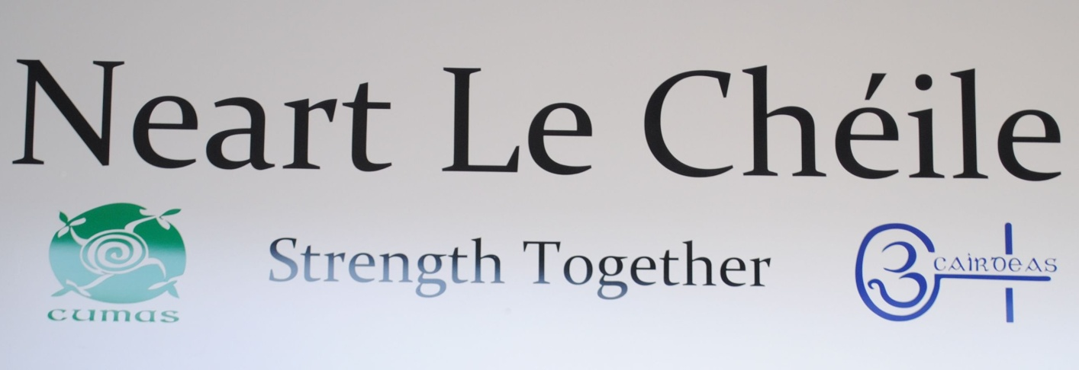

**Neart Le Chéile**

**Annual Report**

**2020**

Old Supermarket, 1-2 Neilstown Shopping Centre,

Clondalkin, Dublin 22

Tel: 01-4573515

# Chairperson’s Foreword

Welcome to the Neart Le Chéile - Annual Report 2020. This year the two projects, the Cumas project and the Cairdeas project continued to offer their services to families and individuals. In writing this annual report we wish to acknowledge the effects the Covid-19 pandemic has had on all involved in the service, including people who use service, staff and the board of management. The projects have adopted new ways of working to continue to provide their services, while operating within the Government’s Covid-19 protocols and guidelines

* Cumas continued their work with families, grandparents, guardians, teenagers and children from aged 4 upwards.
* This work is completed in several ways: play therapy, one to one sessions, group work, counselling support, home visits, schools support, supports around assessment of needs, financial, housing, social and emotional support. The service is implemented on a needs led basis with a holistic wrap around service provided for families and individuals. Throughout 2020 some of these services were delivered remotely by phone or zoom, though social distant visits in gardens or in our premises when guidelines allowed.
* The service offers a number of specific programmes annually or when the need is identified. These include Parents Plus, WRAP (Wellness Recovery Action Plan), Bereavement support, Cognitive Behavioural Therapy (CBT), and the REAL U Sexual health programme.
* We also have several staff trained in the Tusla Meitheal National Practice Model. This has supported a number of families we worked with in 2020.
* NLC aims to work through an inter- agency approach. This includes participation on certain committees such as: South and North Clondalkin Tulsa led family support networks (CFSN), South and North Clondalkin young people at risk (YPAR). Over the course of 2020 we worked in collaboration with North Clondalkin CFSN and Clondalkin Young Minds to respond to issues arising from the pandemic. This included a food outreach and support programme, peer support programmes, mental health training and support, bereavement support, funding for personal protective equipment (PPE) for local services, and lobbying for more accessible mental health and disability services for the community with local TDs and the Oireachtas Mental Health Sub Committee
* SUDS (Service Users Developing Solidarity) members were also busy this year and continued to engage remotely over Zoom meetings.
* SUDS successfully completed a podcast on overdose awareness and prevention as part of International Overdose Awareness Day; in which two members of SUDS interviewed Denis O’Driscoll chief pharmacist at the HSE.
* They also undertook a social media campaign to highlight IOAD.
* They completed a second podcast for recovery month where SUDS interviewed Denis O’ Driscoll and Paul Duffy from the Recovery Academy

These are just some of the highlights of 2020 and I would sincerely like to thank all those who have supported Neart le Chéile in the course of this and in previous years. The board and staff of Neart Le Chéile look forward to your continued support in 2021, as we continue to work with those families engaging with our services as they deal with the issues they face as a result of drug use.

Yours gratefully,

Table of Contents

Chairperson’s Foreword 2

Mission Statement 6

1 Introduction & Overview 7

2 Neart le Chéile: The Cumas Project 9

3 Neart Le Chéile- Cairdeas Project 22

4 Networking and Co-ordination 28

5 Organisational Structure 30

6 Financial Summary 32

7 Thank you 34

# 

# Mission Statement

*“To promote equality by creating and facilitating supportive services which build the capacities of families and individuals to make changes to their lives and circumstances in a way which addresses and reduces the negative consequences arising from the use of drugs in Clondalkin.”*

# 1 Introduction & Overview

**1.1 Introduction**

Neart Le Chéile (Strength Together) is a community-based organisation, which provides two services; the Cumas project which works to support children and families who experience addiction within their families and the Cairdeas project which works with people who use drugs or have a history of drug use on issues that impact on their lives. The company is working hard to continue to maintain and develop quality services for the community we serve.

The board of Neart Le Chéile meets on a monthly basis and is very active in the management of the organisation. It works hard to support the staff in delivering a quality service by continuing to review and plan the work of the organisation on a regular basis. It has a number of sub-groups with defined areas of focus, such as HR and Finance.

**1.2 Overview**

Neart le Chéile provide services in Clondalkin and surrounding areas. People who access the service are coping with a number of issues, all of which were additionally impacted by covid-19. Throughout 2020 our organisation had to make several changes to our service delivery to comply with Government guidelines. This included the delivery of educational and play materials to families, working with a community network to supply weekly food provision to those families most in need and working alongside schools and school completion programmes to remove barriers preventing access to socially distanced learning, including the supply of IT equipment, stationery, and phone and online support. Throughout the pandemic with safety always as a priority, staff met with families in a socially distanced manner. This included meetings in gardens, socially distanced walks, and socially distanced meetings in our building when appropriate. For those that were able to engage online we arranged zoom group quizzes, play through zoom, one to one meetings through zoom and phone calls.

**1.3 Catchment Area**

The area in green indicates the Electoral Divisions covered by Neart Le Chéile (Clondalkin Village, Dunawley, Monastery, Cappaghmore, Rowlagh, Moorfield and Palmerstown West- Quarryvale):

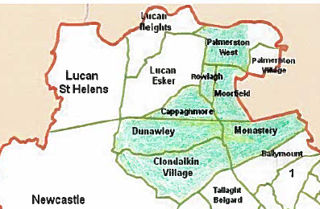

# 2 Neart le Chéile: The Cumas Project

The Cumas project was established in 1998, under the Education and Prevention Strategy of Clondalkin Drugs Task Force Action Plan, as an intervention and prevention service for families affected by the consequences of drug use. Over the past twenty years this distinctive project has grown and developed greatly. Cumas works with all family members from young people aged four years and up, to grandparents. Cumas is unique as it is the only service in the Clondalkin area to provide a service to young people aged 4+, who are affected by the consequences of drug use within their families.

**2.1 Area profile of families**

|  |  |  |  |
| --- | --- | --- | --- |
| **Area Profile** | **Families**  **2018** | **Families**  **2019** | **Families**  **2020** |
| **South West Clondalkin** | 20 | 21 | 19 |
| **North Clondalkin** | 25 | 26 | 24 |
| **Lucan** | 6 | 4 | 3 |
| **Other** | 3 | 2 | 2 |
| **Total** | 54 | 53 | 48 |

**2.2 Interventions**

Cumas works on a needs led basis offering a variety of interventions using a holistic and interagency approach. There are many elements to this work, and it can be broken down into the following categories.

* Family work
* Individual work
* Group work

A large part of the work includes interagency work with other statutory and non-statutory agencies.

*“Family support is about meeting the needs and achieving the rights of Children” (*UNESCO)

In 2020, 48 families engaged with the Cumas project with 75 individuals work over the course of the year; this included different members of the same family attending the service on different occasions for services such as individual work, group work, and family sessions.

Below are two testimonials from service users in 2020:

*“During the pandemic it has been hard on our family. Cumas’ support with practical things such as food has helped lift some of the stresses”.*

*“My son has suffered a lot with his mental health over lockdown. I don’t know what we would have done without the support of our worker in Cumas. It has been a very hard time that is made easier by having someone there to help us. A lot of services were all of a sudden not there for us but Cumas was always there even through this mad time”*

When a family is referred to the project, a needs assessment is carried out with family members, referrers and Cumas staff. This identifies what intervention/support is most appropriate to each family member. This can include individual work, group work and/or family sessions.

**2.3 Case Management**

Staff operate a case management approach, develop responses to the needs of the family and adopt an interagency approach to their work.

|  |  |
| --- | --- |
| Description | Attended session |
| Individual | 75 people x 42 individual sessions by 3,150 sessions - on average one per week |
| Group | 2 groups x 13 individuals were offered 1,092 sessions  Each session lasts between 1.5 to 2hrs. The sessions in summer can run for longer depending on the activities involved. Some groups are biweekly |
| Family session | 48 family sessions = 48 assessments |
| Other meetings | 2 families participated in exit meetings |

It is important to note that due to covid-19 and depending on the level of restrictions imposed by Government at the time, interactions were carried out through socially distanced face to face meetings which included house visits in the garden, socially distanced meetings in our building, video calls and phone calls.

The following table indicates how the service has developed over 2020.

|  |  |  |  |  |  |  |  |  |  |  |  |  |  |
| --- | --- | --- | --- | --- | --- | --- | --- | --- | --- | --- | --- | --- | --- |
|  | **b/f** | **Jan** | **Feb** | **Mar** | **Apr** | **May** | **Jun** | **July** | **Aug** | **Sep** | **Oct** | **Nov** | **Dec** |
| **Active Families** | 43 | 43 | 45 | 46 | 46 | 46 | 47 | 47 | 49 | 49 | 50 | 50 | 48 |
| **New** | 0 | 2 | 1 | 0 | 0 | 1 | 0 | 2 | 0 | 1 | 0 | 0 | 0 |
| **Closed** | 0 | 0 | 0 | 0 | 0 | 0 | 0 | 0 | 0 | 0 | 0 | 2 | 0 |

**2.4 Assessment**

An assessment of needs is carried out on each family and a six-week plan is developed following this assessment. After the six weeks work has been completed the plan is reviewed by the family members and Cumas staff and a plan is agreed. This plan will either recommend that Cumas continues its work with the family, or if it is felt that Cumas is not the most appropriate service, a referral to a more suitable agency is made.

**2.5 Individual work**

Individual work is carried out on a one-to-one basis with a young person or an adult. Individual sessions would be held on average once a week. (More details on page 14).

**2.6 Group work**

Young people and adults while engaging in individual work or upon completing individual work, may also attend a group. Groups are specific to the needs of service users. (More details below on page 15)

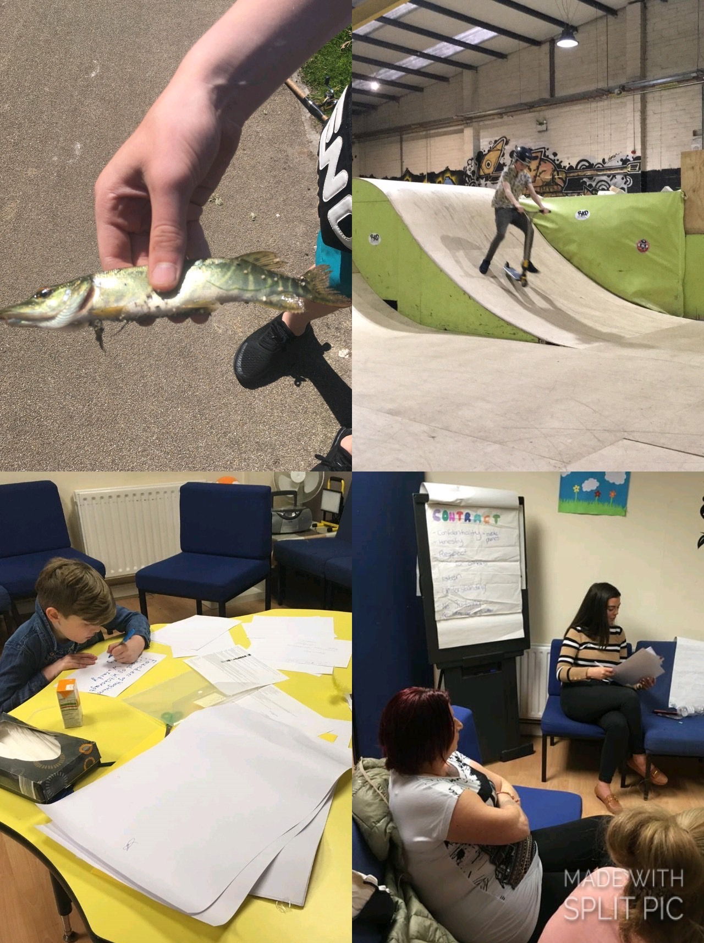**Picture: One to one work and group work**

*Although these pictures are from work undertaken in 2019, the project has been working consistently with families throughout 2020 but given the restrictions in place we were not in a position to document this work with photographs.

**2.7 Family work/sessions**

Family work is an essential part of the Cumas service as it encourages positive relationships between all family members. Sessions with families cover the issues and needs of the family. These can include issues such as disagreements, school behaviour/ routine, attachment building, planning, rules, boundaries, parenting, life and family skills, fun, cooking etc. Family sessions can be either weekly or monthly. Family meetings including all family members are conducted to look at issues arising and to put plans in place to deal with those issues. (More details on pages 13 &14)

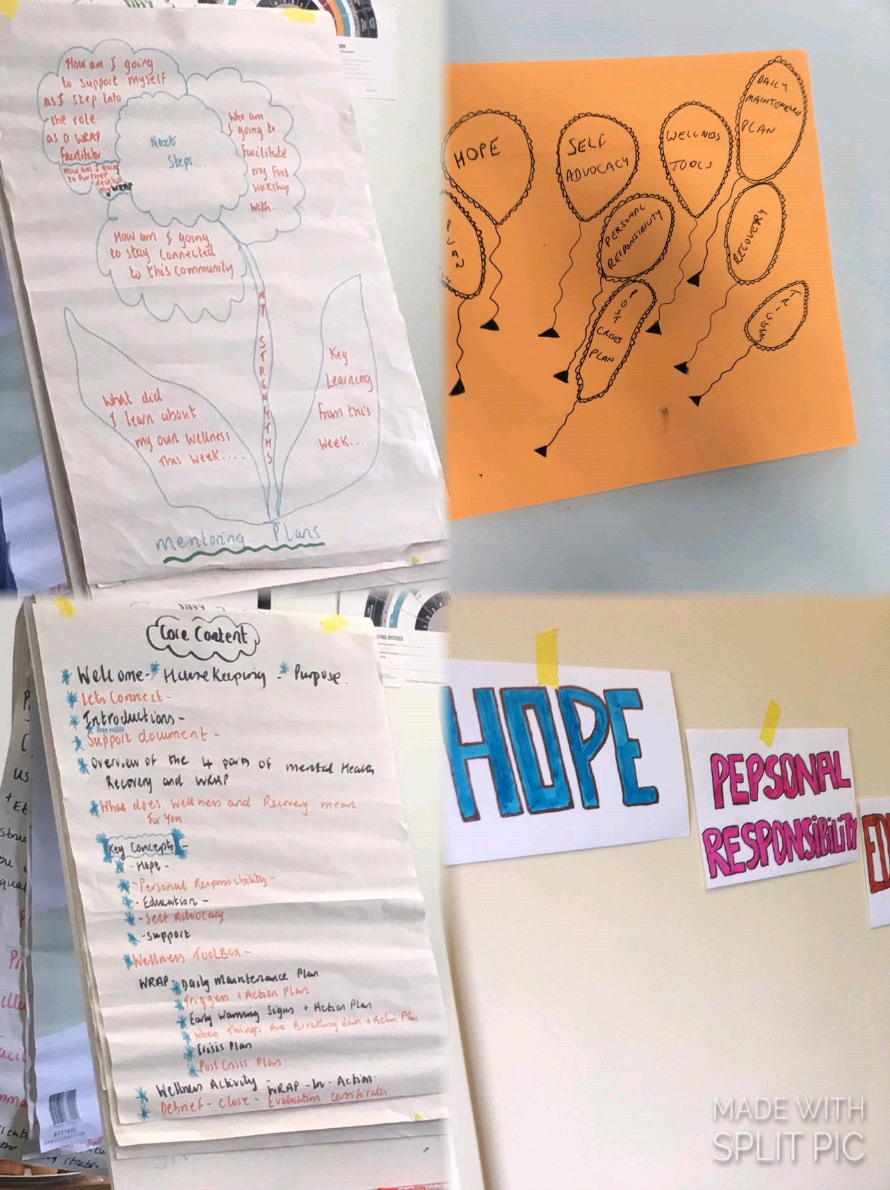

*Picture above – WRAP Training*

The work carried out with families by Cumas is further illustrated below.

**Examples of work with families are as follows:**

|  |  |  |
| --- | --- | --- |
| **Input** | **Output** | **Outcomes** |
| * Staff offered one to one support to all families. * Staff carried out needs assessment with families. * Staff offered practical support on issues that families face * Staff have participated in case conferences with Tusla the Child & family agency * Staff have engaged in meithael process with a number of families | * 48 families accessed the Cumas project of family sessions were attended * Care plans were completed or reviewed for all families over the course of the year. * 2 completed their engagement with the Cumas project at the end of the year * A number families were supported to access entitlements * Staff supported families with housing issues, addiction issues, counselling and other needs arising | * Improved engagement with services * Issues resolved, such as housing, welfare entitlements accessed. * Improved * communication within the family * Improved family routine |
| * Staff work with a number of families, with HSE involvement for child protection (active) and some cases closed, as part of social work care plan. | * Actively worked with the Tusla Social Worker together with families to implement a care plan * Cumas referred 19 cases to duty social workers * Interagency approach- HSE case conferences and meithael attended | * All agencies involved working together * Family focused clear care plan |
| * Staff while working with families may identify needs and make referrals to other parts of the Cumas service or other agencies within the community statutory /non-statutory * Cumas staff also supported family members to access support from hospitals, GPs, and community based mental health services, if suffering from mental health or emotional crisis. | * Families counselling * Play therapy (our play therapy had to be suspending due to Covid-19) * Needs assessment * Educational assessment * Child protection concerns * Psychological assessments * Individual counselling * Assessment of needs for children | * Improvement in parent/child relationships * Safe space to explore feelings/situation * New coping skills * Extra supports put in place * Referred to appropriate service while still receiving support from Cumas * Links built with other services and work using interagency approach best outcomes for families achieved * Supports put in place in school, etc. ensuring young people remain in education |
| * Staff represent the project on a number of forums. | **These include:**   * North and South Clondalkin Young people at risk (YPARC) * North and South Clondalkin Family Support Network (CFSN) * Covid-19 Response committee as mentioned above | * This interagency approach supports the best outcome for children and families * Improved relationships with agencies in the community * Better communication with agencies * Inclusive wrap around support service |

**2.8 Referral & Assessment Process**

Referrals are received from a variety of places such as; self-referrals (families refer themselves), statutory agencies and non- statutory agencies. Below is a list of all agencies we have received referrals from 2018 to 2020:

|  |  |  |  |
| --- | --- | --- | --- |
| **Referrals** | **2018** | **2019** | **2020** |
| **Self-referrals** | 38 | 43 | 39 |
| **Cairdeas** | 1 | 2 | 1 |
| **CASP** | 2 | 3 | 3 |
| **Clondalkin Tus Nua** | 3 | 1 | 1 |
| **Dochas** | 0 | 0 | 0 |
| **Extern** | 0 | 0 | 0 |
| **Social Worker** | 5 | 2 | 2 |
| **School** | 0 | 2 | 2 |
| **Total** | 54 | 53 | 48 |

**Referrals (January- December 2020)**

Cumas believes families have many strengths and coping skills, and staff work with families to support them to improve their skills as well as to develop new skills to overcome the issues that they are referred to the project with. The issues that families face are wide and varied and the impact of these issues can be different for each family member.

Parental drug use can impact on children’s daily lives, emotionally and physically. There can be a lack of parental guidance, structures and/or routines. Emotional difficulties can be a result of any one of a range of issues including; bereavement within the family, parents separating, a family member going to prison, violent attacks on the home, etc. There may also be welfare concerns, child protection concerns, lack of engagement with other services, difficulties in school, personal development, grandparent parenting grandchild, parental support, lack of engagement in school, at risk of losing a place in school, financial difficulties, etc.

**2.9 Individual Work**

Throughout 2020 individual work was undertaken in line with current Government guidelines. It was completed outdoors, indoors with social distance and on zoom. Individual work is carried out with young people, adolescents and parents/grandparents. Interventions used include; life story work, sensory work, planned work, support, referral relating to individual’s needs and issues arising.

**2.10 Group Work**

Throughout 2020 group work was undertaken in line with current Government guidelines and included a mix of socially distanced face to face work and zoom. On completion of individual work, as needs are identified a group is formed- normally with 4-6 participants. The group is created with a specific topic to be covered. Groups encourage peer interactions and social skills, while working on specific areas/issues. Child/adolescent, parent/ guardians and grandparents all attend groups. Many of the Cumas staff are fully trained in the Parents Plus parenting programme. Parenting groups take place at regular intervals in a group setting and support is offered on a one-to-one basis with parents. The parents’ group that was previously running, ceased in 2020. This was due to several reasons. Parents continue to receive individual support. When Government restrictions are lifted, we will evaluate if a new parents’ support group is needed.

Two staff members were trained in the (WRAP) in 2019. The aim of WRAP is to support service users to focus on their own wellness and how to implement this daily to support their mental health. In 2020 due to Covid-19 restrictions this programme did not happen. However, we did link both staff and service users into the online WRAP programme run by Suicide or Survive SOS.

The following are examples of group work that has been facilitated by Cumas staff

|  |  |  |
| --- | --- | --- |
| **Input** | **Outputs** | **Outcomes** |
| **Group 1** | | |
| 15-16 year old Girls Group x 5 participants  With a focus on:   * Personal Development * Education support * Bereavement * Anxiety support | * 5 participants * Use of zoom * Socially distanced outdoor and indoor meetings * Peer support and conversations * Suitable adult support | * Improved anxiety around many changes over the year * Focus and support throughout the pandemic * Improved interaction with staff * Improved interagency work on specific issues * Maintaining links with friends during Covid-19 was very beneficial for the girls. |
| **Group 2** | | |
| 18-20 year old mixed gender group x 8 participants  With a focus on:   * Personal development * Job support * Education support * Lone parent support * Housing support * Relationship support * Suicide ideation support * Bereavement | * 8 participants * Use of zoom * Socially distanced outdoor and indoor meetings * Peer support and conversations * Suitable adult support | * Improved anxiety around many changes over the year * Focus and support throughout the pandemic * Improved interaction with staff * Improved interagency work on specific issues, housing, education etc. * Maintaining links with friends during Covid-19 was very beneficial for the participants of the group. |
|  | | |

**2.11 Family & Play Therapy**

The Cumas project, as part of its need led service also offers families access to a counsellor and children access to play therapy as an extra support where possible and budget permitting. During the pandemic our counselling service has continued, online, by phone and face to face when permitted. Unfortunately, due to the nature of how it is completed our play therapy did not happen for most of 2020, it was not possible to provide this service due to Government restrictions. However, the children involved were reallocated back to their key worker so they were not left without a service. The project will review how it will proceed with play therapy, once Government guidelines and funding permit. 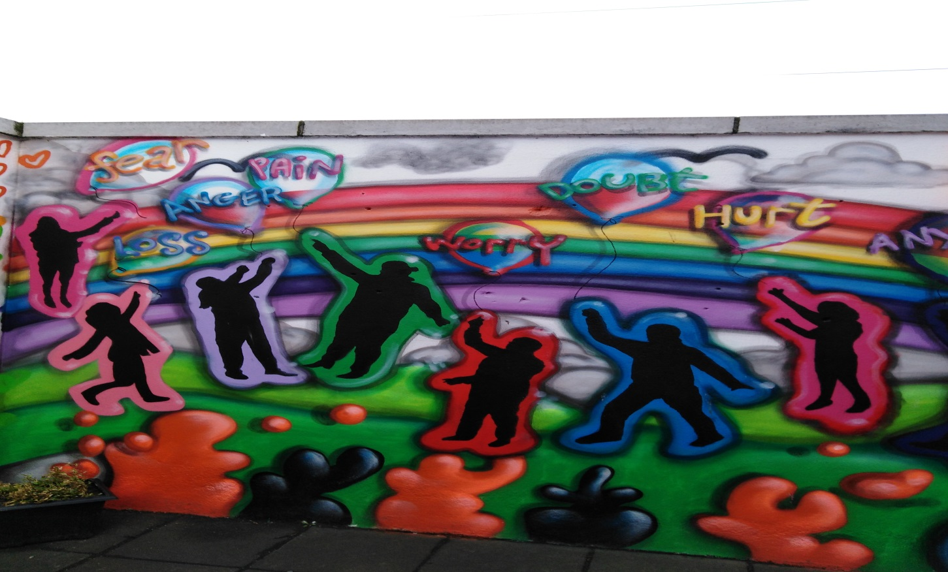

**Background and rationale for family therapy**

Family Therapy has been part of the wrap around service provided by Cumas as far back as 2006, with play therapy starting in 2015.

**Family Therapy (FT)**

In our service the aim of family therapy is to involve families in solutions that offer benefits to the whole family, this is regardless of the origin of the problem, and regardless of whether the service users consider it an "individual" or "family" issue. This involvement of families is usually achieved by their direct participation in the therapy session.

**Play Therapy (PT)**

Play therapy is a form of counselling or psychotherapy in which play is used as a means of helping children express or communicate their feelings.

**How we implement our wrap around service**

Due to the nature of working with families of sometimes generational addiction, we consistently engage families that have issues due to ongoing trauma. We also see a significant amount of hidden harms that are quite concerning. Families need to be supported to realise the impact that this is having and to put in place protective factors to combat the risk factors that often accompany this. To ensure this we offer a key worker from our team, where appropriate, we also refer small children to play therapy and older teenagers and guardians to family therapy.

This type of approach is only used for our families that would be "most at risk”, due to budget constraints. Although we can only offer this type of wrap around service to our highest risk families, we do not always have the resources for family therapy and play therapy to engage in the appropriate response as often as necessary. However, the feedback received from families and the progression of those families has yielded very positive responses and results, from this approach.

**Why Cumas?**

We have over the years explored other local therapies, but the waiting lists can be very long, sometimes years. Access to these therapies usually also require very specific criteria rather than general work for ongoing issues within the family or with the child. Most importantly, families feedback to us is that they are very comfortable in our service. They feel safe going to a therapist on the premises as they know that therapist works with the project on an ongoing basis. Families have expressed that they appreciate that they do not need to keep retelling their trauma, as Cumas is already aware of family situations and has permission to share this with the therapists. There is also a clear progression path for families after the therapy is over.

**Funding context**

In any one year we can work with between 40-50 families. Our family therapy budget is €6,100 (mixture of Tusla and Drugs Task Force funding). That is roughly 85 sessions per year. We do not have a budget for play therapy, and this has in the past been paid for through sessional worker payments. We have a full complement of staff this year, so we do not have extra funding for any play therapy. We have engaged in fundraising events for both therapies at different times. Although family therapy and play therapy has been a response to support our families for many years, we have never had consistent secure funding. We have to reapply each year for the €6,100 and are not always guaranteed to get it.

Due to the nature of how we receive our funding we often have families and children on our waiting lists for family therapy and play therapy for long periods. We would also like to offer a more preventative strategy with families and children but we very rarely have the opportunity to do this. Due to funding constraints it often ends up being a crises response.

The table below gives the breakdown of these therapies/ initiatives:

|  |  |  |
| --- | --- | --- |
| **Inputs** | **Outputs** | **Outcomes** |
| **Family therapy** |  |  |
| 2 sessions per week  3 families engaged  Total of 5 people  The numbers are lower this year as during Covid-19 the families involved were in much more need of the service. This meant the therapist stayed with the same families for the majority of the year. | * Two/three family sessions once per week * Number of families (3) * Families come together to deal with complex issues * Safe space * 6/8 weekly reviews with family, Cumas family key worker and family therapist, all information discussed with permission of family * Majority of sessions this year done by zoom or phone. | * Improved communication * Families supported to bring about change * Staff supported families to maintain changes * Ensuring best outcomes for all, clear work plan, goal setting, ensuring that Cumas staff give support where needed * Ensuring therapy is appropriate and is meeting needs of family |
| **Play Therapist** |  |  |
| **Provided to 3 (children) - existing service users**  3 children were offered play therapy based on the needs of their family for twelve weeks  Finished in March due to Covid-19 | * Play therapist worked with the children giving support to deal with family circumstances, complex issues * Child and family continue to engage in Cumas service. Most would have completed individual work but felt the need for additional support to deal with complex issues | * Improved understanding. * Safe space * Works at young person’s pace where they take the lead * Time to work through issues in a non-threatening environment * Less angry, better communication, happier, new coping skills, bereavement support |

**2.12 Networking in the pandemic**

2020 was a very different year as a result of the pandemic and during this time we felt it was more important than ever to take a more collaborative approach to our work. In March 2020 we engaged with a number of other services through zoom to firstly tackle the problem of food poverty during this crisis and a local food drive was set up. As a service we referred families into the food drive, offered transport and sought an extra €5,000 in funding for it. Through these meetings it became apparent that there were many other issues arising in the community as a result of covid-19. A number of other subgroups were set up to respond to the needs that NLC are involved with, these included:

**Bereavement subgroup**

A bereavement Facebook page was set up to provide a space for family members to share stories of their loved ones. A candlelight vigil (online) was also held to support families at a time of isolation when our usual rituals around death could not be observed.

**Mental Health subgroup**

This consisted of a number of responses to support the community. It also aimed to support local staff through this difficult time. NLC arranged a mental health morning in conjunction with Suicide or Survive (SOS). We had 24 staff and 7 agencies involved in the session. The feedback was very positive. Alongside this NLC arranged a "peer support" check in with staff in a number of agencies once a month to discuss the impact that the pandemic was having on them and their mental health.

**Disability subgroup**

We have had feedback from a number of families in the area that during this pandemic they have lost support in a number of areas in regards to disability. This includes but is not limited to, less support from home careers, long waiting lists for assessment of needs, services being closed outside of the home that children/adults previously engaged in but nothing put in to replace them. Families of children with special needs or disabilities have been disproportionally negatively affected by this crisis. NLC has arranged a number of meetings with local TD's to respond to these issues for families. We are also highlighting the mental health shortcomings during these meetings. This work is ongoing.

**Back to work subgroup**

This group has approached South Dublin County Partnership to set up a CE scheme which would see CE workers being trained in specialized cleaning in response to covid-19. We have also secured €17,000 from South Dublin County Council for PPE equipment and lap tops for community services. These pieces of work are ongoing and there are many aspects involved but this is a summary of some of the work.

It is important to note that the above are only some of the responses to the issues going on in the community during this crisis. The local services have taken a collaborative approach with NLC being a big part of this response. The other services include, Tusla, School Completions programme, local youth services (Crosscare), Archways, Blueskies, local family resource centres, ISPCC, Gardai, South Dublin County Council, SDC partnership, CYPSC Co ordinator, local family support projects, schools and the local parish office. We will all continue to work together during and beyond this crisis for the improved quality of life for our service users.

# 3 Neart Le Chéile- Cairdeas Project

The Cairdeas project is a community-based organisation which offers services to thosewho use drugs. The project works to community development principles and adopts a person-centered approach to its work. We promote harm reduction and seek to promote the full participation of people who use drugs in their community in order to break down the barriers to social inclusion. Cairdeas operates a low threshold service. Our services are as follows:

* An Advocacy Service
* Stepladder Training Course. SUDS -Service Users Developing Solidarity (a forum for people who use drugs)

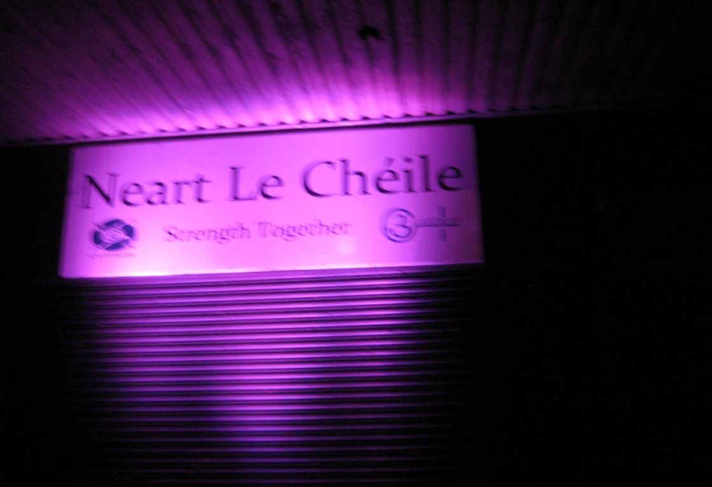

**3.1 The Advocacy Service**

The Cairdeas project advocacy service is an ongoing process aiming to change attitudes, actions and policies by influencing people and organisations with power systems and structures at different levels for the betterment of those who use drugs. The service operates on a case-by-case basis in which staff will advocate on cases as they present to the project

***The Advocacy service has dealt with a range of issues in 2020, which include:***

* Homelessness/housing/tenancy
* Access to treatment, health and mental health
* Family and relationship issues – Court issues

***Area profile of those using the Advocacy Service***

***30 advocacy cases were dealt with throughout 2020 as follows-***

|  |  |  |  |  |
| --- | --- | --- | --- | --- |
|  | **North Clondalkin** | **South West Clondalkin** | **Lucan** | **Other** |
| Females | 5 | 1 | 1 | 1 |
| Males | 11 | 6 | 3 | 2 |

**Advocacy Service**

|  |  |  |  |
| --- | --- | --- | --- |
| **Action** | **Outputs** | **Outcomes** | |
| Provide an Advocacy Service to those who use drugs or have a history of drug use on a case by case basis.  Advocate on behalf of a person until the case is either resolved/ or satisfactory outcome sought/ or the person is in a position to advocate on their own behalf. | * 30 people accessed the service of which 7 were new service users   The range of issues throughout the advocacy service were as follows;   * Access to homeless list/ services * Access to daft website (seeking accommodation for rent) * Bus pass application for those on disability payment * Access to treatment options * Referral social worker * Addiction key work referral to CASP/ Tus Nua * Access to counsellor * Access to education/training * Referrals for family/ child | * Service Users accessed housing list   with a view to getting rent allowance/ accommodation   * Homeless service users accessed hostels/ drop in for homeless people (meals, showers etc.) * New bus passes/ replacements of lost one’s |

Offering the advocacy service to those who use drugs enables the project to engage with service users while keeping informed of the issues they face in order to feed into policies. It allows the staff to build relationships with the service users. The project staff work to build relationships with other agencies in order to make the service more accessible to service users. The process continues until such time as the issue is resolved or until the service user is ready to advocate for themselves.

**3.2 Stepladder Training Programme**

The Stepladder training programme is a pre-development training course.

Stepladder targets people who use drugs, who are on a methadone programme or are drug free, although some are not necessarily stable in their drug use. The majority of people accessing the programme have not participated in any form of training or further education since they left school. Almost all of the people are early school leavers.

The aim of the training is to create opportunities for people to build their skills in education and training while building their confidence and self- esteem. The training provides participants with not only a routine in their daily lives but also a social outlet.

The following table illustrates progress:

|  |  |  |
| --- | --- | --- |
| **Action** | **Output** | **Outcomes** |
| To deliver Stepladder training course in South West Clondalkin to 12participants  **Modules covered:**   * Stress management * Steps Personal Development Programme * Adult Literacy * Personal / interpersonal skills | * 11 participants started in   March in South West Clondalkin   * 11 participants were actively participating with the course when it had to be cancelled due to Covid 19 | Staff continue to support participants by phone /zoom |
| To offer an advocacy service to participants of stepladder training | All stepladder participants availed of the Advocacy Service in Cairdeas in 2020 |  |

**3.3 SUDS- Service Users Developing Solidarity**

The following table illustrates progress:

|  |  |  |
| --- | --- | --- |
| **Action** | **Output** | **Outcomes** |
| * 48 meetings for a 2 ½ hour sessions per week. * 7 service users attended SUDS * These meetings were conducted on Zoom; some members could not participate due to problems with broadband, etc. * When the Governments’ guidelines allowed, meetings were held on the premises. | * Produced two podcasts * 5 Local services involved * As part of IOAD- Pictures of each service were posted on social media * An article was published in a local newspaper. There was also a twitter awareness campaign which resulted in a tweet reaching 6,500 people * Link on DRUG.ie * Members of SUDS invited to Launch | * Podcast-Discussing Recovery   with Denis O’Driscoll and Paul Duffy   * Podcast-Discussing Overdose with Denis O'Driscoll * Total downloads 192   **Country Listens**  1 Ireland 67.7 %  2 United States 18.8 %  3 Australia 4.2 %  4 Canada 3.6 %  5 India 3.6 %  6 United Kingdom 1.0 %  7 Guyana 0.5 %  8 Netherlands 0.5 % |

**SUDS work in 2020 included the following;**

Through exploring what approach to take for raising awareness of overdose in the community and to mark International Overdose Awareness Day (IOAD), SUDS decided the approach would be a social media campaign which aligned with the objectives established at the beginning of the year.

This resulted in SUDS planning and producing a podcast that was shared across all social media platforms with support from a professional podcasting company, The Podcast Studios, to mark IOAD. On the podcast, SUDS discussed with guest speaker, Denis O Driscoll, Former HSE Chief Pharmacist, and Project Lead with the Naloxone Demonstration Project the issue of overdose, ways to recognise it, ways to prevent it and ways we all, individually, as a community, and nationwide, can reduce the number of lives lost through overdose through education, awareness and getting involved in spreading the word.

SUDS also initiated a collaborative community effort with five Drug Support Services in Clondalkin to light up the respective buildings in purple in solidarity and support for all those who lost their lives through overdose and their families, and to raise awareness regarding the issue of overdose in the wider community. These pictures were posted across Twitter and Facebook on August 31st 2020 and made this a community wide effort in support of IOAD. To make this possible SUDS rented a lighting system for outside the building and SUDS members organised in collaboration with the participating services nights to attend each service and take pictures to have ready for distribution throughout social media on August 31st, in remembrance of those who lost their lives through overdose. SUDS also organised the lighting of a candle in local services on August 31st where keyring torches were distributed to service users with the #overdoseawareness logo on each as well as a floral candle arrangement for each organization to remain lit on the day. In organising this, SUDS had to source the torches and cards for each package and prepare the displays to be set up in each service.

The events organised above were done in collaboration with CDATF. SUDS spent many meetings through zoom focusing on what to do, how to do it and why before settling on the above ideas. The energy and enthusiasm that SUDS brought to each meeting made it possible to plan and subsequently progress with the ideas above.

To organise the diverse number of events above, each with its own challenges, and whilst meeting remotely the group became very task orientated with all involved taking responsibility for a task weekly to bring it all together. Having IOAD to focus on through this period really seemed to energise the group. When the plans were established everyone committed to making them happen against the challenge of working remotely.

The result of this work was the production of a successful, far-reaching podcast that garnered much attention and praise and the creation of a platform for SUDS to continue to raise and discuss issues of interest or concern. Subsequently SUDS produced another podcast discussing Recovery for Recovery month with guest speakers Denis O’Driscoll, and Paul Duffy, from the Recovery Academy Ireland. This podcast was also shared and made available across all social media platforms.

Using SUDS newly established twitter page and Facebook to promote our campaign, we got a lot of support from services within the Dublin region and also further afield, a goal we had set for ourselves at the beginning of 2020.

As a result of the whole campaign, SUDS were invited to, and attended the launch of IOAD Ireland through zoom.

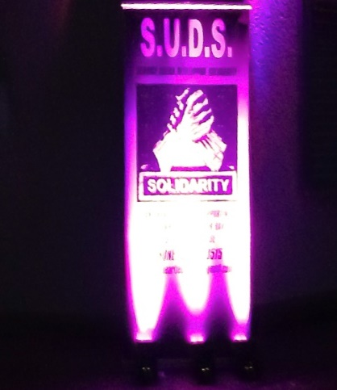

# 4 Networking and Co-ordination

The project also engages in networking and co-ordination in order to influence and support organisations who offer services for those who use drugs and their families. We participate in structures which bring together organisations to have a collective say in the area, by participating on local Fora to highlight the needs of service users and to work with the local community to find solutions to the issues that Clondalkin faces.

**4.1 To engage in Policy work and Networking**

|  |  |  |  |
| --- | --- | --- | --- |
| **Action** | **Outputs** | | **Outcomes** |
| **Policy** | | | |
| To engage with other organisations , agencies and networks at a collective level to bring about changes at policy level and perhaps co-ordination | * Attend the Clondalkin Drug Task Force * Attend treatment and rehabilitation subgroup of the Clondalkin Drugs Task Force * Attend the prevention subgroup of the Clondalkin Drug Task Force * Family support network meetings * Attend Clondalkin Community Health House meetings * Spideóg | * Influenced policy in relation to drug services locally * Influenced funding to the   benefit of drug users   * Influence services for families. * Improved interagency approaches * Engage young people/be aware of issues facing young people at risk of losing places in education * Work on interagency approach to best support young people & their families | |
| To ensure the issues concerning the drug using community are voiced until such time that the forum members are able to participate at this level | * Worked on a range of issues * Profile of Cairdeas Project raised in the broader community * Anti-social behaviour * Social exclusion etc. * Developed stronger Links with the Gardaí | * To continue to build relationships with the community in South West Clondalkin as the project does not have a permanent presence in that area. | |
| **Networking** | | | |
| Community Platform  PPN Public Participant Network  Joint Policing Committee(JPC) | * Attend Community Platform * Social inclusion Pillar * From the PPN linkage group elected to JPC * JPC Subgroup on Drugs | | * Joined new structure to participate in order to work to improve social inclusion. |
| Individual agency approaches | * Exchange and gather information * Make appropriate referrals as required to agencies such as;   South Dublin County Council. Including RAS team   * Local Employment Service * Cumas * Probation and Welfare * HSE- Integration Service * HSE- Addiction Services/ * Doctors * Station On * Child Protection Social Work Department * CAMHS * Pieta House * Carline Centre | | * Service users of the project have gained easier access to these services as a result of the approaches taken by the project |
| Attend/host statutory & non-statutory interagency meetings | * Case conferences- HSE * School meetings * Public Health Nurses * Carline * Social Work Department-Child Protection & Medical * Youth Advocacy Project * Extern * CASP * The Clondalkin Family Support Network | | * Care plans developed and reviewed with all agencies involved to ensure best outcomes for families involved * Ensure each agency is aware of their role when working with families. |

The impact of this work is that we support organisations who deliver services to those who use drugs, and also to influence their policy for the betterment of our service users. We also aim to co-ordinate work between organisations and to work to have a collective response to issues as they arise.

The staff aims to maintain a good working relationship with staff in other organisations in order to support the work of the project, which can create challenges as it may question organisations policies and practices. Neart Le Chéile is affiliated to a number of organisations that would be supportive of its work including:

* Amnesty International
* South Dublin Rights Platform

# 5 Organisational Structure

**5.1 Neart Le Chéile Board of Management**

|  |  |  |  |  |
| --- | --- | --- | --- | --- |
| **Name** | **Role** | **Organisation** | **From** | **To** |
| Michelle Kearns | Director |  | 2012 | Present |
| Andy Lane | Director | South Dublin County Council | 2012 | Present |
| Patricia Reynolds | Director |  | 2012 | Present |

**5.2 Staff of Neart le Chéile**

|  |  |  |  |  |
| --- | --- | --- | --- | --- |
| **Name** | **Project** | **Role** | **From** | **To** |
| Ann Corrigan | Neart le Chéile/ Cairdeas | Manager | 2012 | Present |
| Lisa Collins | Cairdeas | Project Worker | 2012 | Present |
| Yvonne Mullen | Cairdeas | Sessional worker | 2019 | present |
| Alison Finn | Neart le Chéile / Cumas | Deputy Manager | 2018 | Present |
| Ashling O Sullivan | Cumas | Child/family worker | 2019 | Present |
| Laura Peel | Cumas | Child/family worker | 2018 | Present |
| Sinead O Regan | Cumas | Child/ family Worker | 2012 | Present |
| Vivienne Nolan | Cumas | Family Worker | 2012 | Present |
| Orla Ryan | Cumas | Family Worker | 2012 | Present |
| Elaine O‘Keeffe | Cumas | Family Worker | 2013 | Present |
| Debbie Keogh | Neart le Chéile | Receptionist | 2012 | Present |
| Declan Geraghty | Neart le Chéile | Bus Driver | 2016 | Present |
| Joy Winterbottom | Contracted by Cumas | Family Counsellor |  |  |

**5.4 Funding sources**

|  |  |  |
| --- | --- | --- |
| **Source** | **Funding** | **Funding** |
| HSE / Clondalkin Drug Task Force | Cumas | Cairdeas |
| Once off grants Clondalkin Drug Task Force | Cumas |  |
| Department of Social Protection | Cumas |  |
| Family Support Agency | Cumas |  |
| Healthy Ireland fund |  | Cairdeas |

# 

# 6 Financial Summary

Neart Le Chéile took over the financial responsibility of Cairdeas and Cumas following the transfer from Clondalkin Drug Task Force at the end of 2012. Neart Le Chéile employs a part time financial administrator to manage the finances and report to the Board. Payroll is subcontracted out to a private contractor and the finances are overseen by the Finance sub- committee of the Board of Management.

Neart Le Chéile has completed its financial audit for 2020 and the following extracts are taken from the Director’s report and Financial Statements for the year ended 31st December 2020 and approved by the Board on the 28th July 2021.

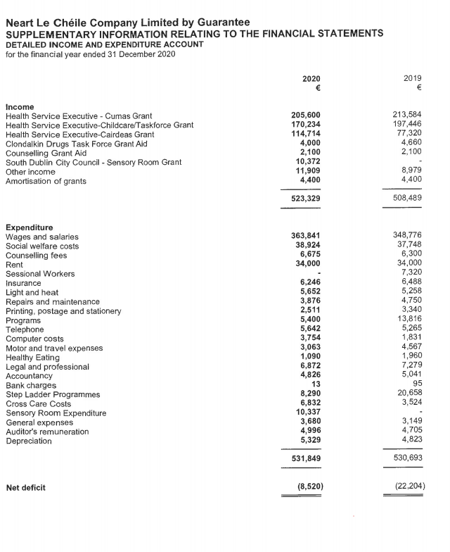

# 7 Thank You

The management and staff of Neart Le Chéile would like to sincerely thank all involved for their ongoing support to the very essential services we provide to people in the community. We look forward to the year ahead and endeavour to continue maintaining, delivering and developing these services.

